Relational databases - Relational databases use a rigid schema that organizes collections of data into tables with rows and columns, where relationships exist between different tables.

Amazon Relational Database Service - Amazon RDS is a *managed* relational database service that handles routine database tasks such as backups, patching, and hardware provisioning. ( Multi-AZ deployment and automated backups ,  network isolation, encryption in transit, and encryption at rest).

Amazon Aurora - Aurora is a managed relational database designed to help reduce unnecessary I/O operations.

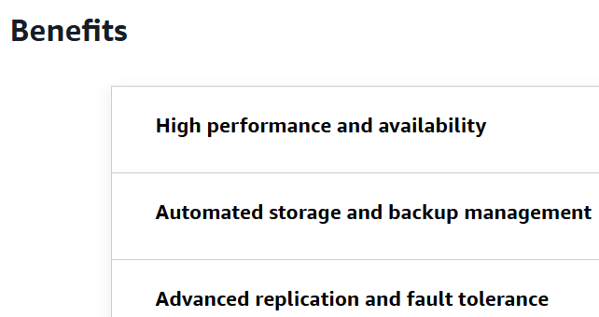

NoSQL databases - NoSQL databases use flexible data schemas for storing and retrieving many different types of information.

Amazon DynamoDB - DynamoDB is a fully managed NoSQL database service that provides fast and predictable performance for both document and key-value data structures.

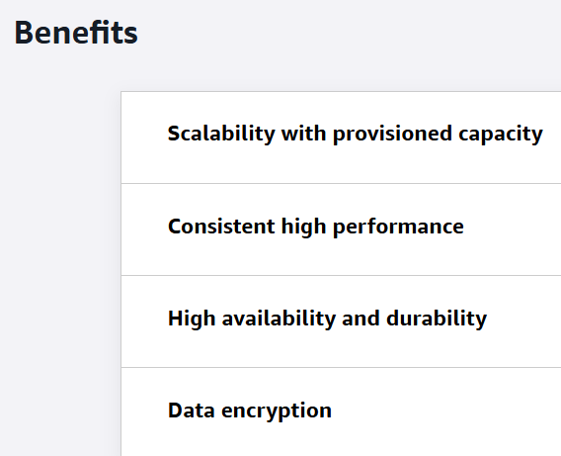

In-memory caches - An in-memory cache is a high-speed storage layer that *temporarily stores frequently accessed data in* a computer's main memory, or *RAM*.

Amazon ElastiCache - ElastiCache is a fully managed in-memory caching service that was built to help reduce the complexity of administering in-memory caching systems.

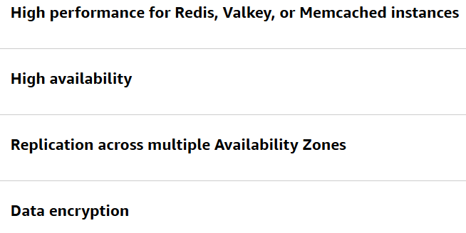

Amazon DocumentDB - Amazon DocumentDB (with MongoDB compatibility) is fully managed service designed to handle semistructured data, which is information that doesn't conform to rigid relational schemas. Amazon DocumentDB is a MongoDB-compatible database, so it manages JSON-like documents with dynamic schemas.

Some examples of practical use cases for Amazon DocumentDB are content management systems, catalog and inventory management, and user profile and personalization systems.

Benefits

MongoDB compatibility, Performance and scalability, Increased read throughput

AWS Backup - AWS Backup streamlines data protection across various AWS resources and on-premises deployments by providing a single dashboard for monitoring and managing backups. It eliminates the complexity of managing multiple backup strategies by supporting multiple storage types.  It offers flexible scheduling options, encryption capabilities, and cross-Region backup support for enhanced disaster recovery.

Benefits

Centralized backup management, Cross-region backup redundancy

Amazon Neptune -Neptune is a fully managed, purpose-built graph database service that manages highly connected data sets, like those used in social networking applications.